



01

Promoting the Australia Awards Fellowship
Updated: November 2024

Promoting your Australia Awards Fellowship
Congratulations on your successful application for an Australia Awards Fellowship.

It’s never too early to think about ways to promote your Fellowship (including before your Fellows arrive!). This document includes some suggestions to help you get started, and also provides guidance about how to reference the Australian Government’s support for your program and how to use our preferred branding.

Accompanying this guide is an Australia Awards Fellowships Promotions Pack, which includes logos and templates that are ready for you to create a number of co-branded communications products.

The pack includes a template for a media release, Fellow profile, PowerPoint presentation, report/publication template as well as Australia Awards Fellowship logos.

Please remember, as part of your Grant Agreement, you are required to seek the Department of Foreign Affairs and Trade (DFAT) approval of any external communications. The Australia Awards team is keen to help by promoting your Fellowship (where possible) through our DFAT channels.

Logos and co-branding

The Australia Awards Fellowships logo has been provided for co-branding your communications materials because it is important that the Australian Government’s contribution is recognised, and for Fellows to know they have received a prestigious Australia Award. The logo’s can be found in the Australia Awards Resources page

The Australia Awards Fellowships logo should be placed in the most prominent position (usually top left) of any communication product that uses an Australia Awards template.

For products using your own branding please include the Australia Awards logo in the following order of prominence:

- Australian Host Organisation logo
- Australia Awards Fellowship logo
or
- Australian Host Organisation logo
- Partner Organisation logo
- Australia Awards Fellowship logo
A more detailed Australia Awards Branding Style Guide is available on request.

Media releases

Sending out a DFAT cleared* media release prior to the commencement of your Fellowship is a great way to let people know about your organisation and your program’s objectives. A shell template (see item 2 in the pack) for drafting co-branded media releases has been included in your Promotions Pack which includes a compulsory Australia Awards Fellowships disclaimer. The template also provides some key messages, which we would encourage you to use.
*Clearance - please send all media releases to fellowships@dfat.gov.au for clearance with a minimum of 21 business days’ notice prior to releasing.

Offering an ‘exclusive’ to a local newspaper or journalist
Proactive placement of a story is a good way to gain coverage. You might like to consider inviting a local journalist to an event which provides good photo opportunities, for example, a function where Fellows are in traditional dress, or a meeting with local government representatives. You may like to set up a meet and greet with Fellows participating in field work or arrange for a local journalist to interview one of your outstanding Fellows.

Articles for websites or newsletters
News articles published through your own print and electronic channels are a great way to highlight your program’s achievements. They can be published any time and are easily reproduced through our DFAT channels. Your own channels might include your organisation’s website, your partner’s website, your newsletters or relevant industry publications.
Please send any communication products you think DFAT might be interested in cross promoting to fellowships@dfat.gov.au. We may publish the content on the DFAT or Australia Awards websites, in electronic newsletters, Annual Reports etc, or use social media to link to your website.

Social media
We strongly encourage you to use social media (Twitter, Facebook, Instagram, YouTube etc.) to promote your Fellowship. Of course, by sharing content with us, you are also sharing with our many followers, extending your reach.

- X – AustraliaAwards can re-tweet your messages to over 18,000 followers. Please use the hashtag #AustraliaAwards Fellowships and our tagline #makeadifference. Please consider linking to us - our twitter handle is @AustraliaAwards

- Facebook – we have many highly visible Australia Awards pages managed by our Diplomatic Posts. When referring to Australia Awards on Facebook please use the hashtag #AustraliaAwards Fellowships and our tagline #makeadifference.

- Instagram – Australia Awards has a wide platform of over 115,000 followers, this is a great way to share content through Instagram posts and stories. Please use hashtags #AustraliaAwards Fellowships and our tagline #makeadifference.

- YouTube – DFAT has its own YouTube channel including an Australia Awards playlist. We would be very happy to assist you in planning a video of your Fellowship and may be in a position to collaborate and upload content to our site.

Fellow profiles

You may like to consider profiling one or more of your outstanding Fellows. Firsthand stories often make great news content, providing a personalised, more intimate account of a Fellow’s experience which appeals to the reader. Consider using Fellows who are comfortable being interviewed, have an interesting background, have a high profile in their country of origin, or are thought to be leaders in their fields.

You may use either the Australia Awards Fellowships Profile template or the Fellow Profile Questionnaire Template found on the Australia Awards Resources page and includes a set of standard questions you can give to your Fellows to assist them with writing their own profiles which you can then edit. A good photo will lift a written profile and may help with securing external media placement. Please send profiles you would like DFAT to consider promoting to fellowships@dfat.gov.au

Please include links to the profile on your own channels, photo captions and photo by-lines and tagging, e.g. courtesy
University of Sydney.

PowerPoint Presentation
A welcome presentation for Fellows has been added on the Australia Awards Resources page.
A blank template for you to create your own has also be added.

Photos
A good photo is an excellent way to promote your Fellowship and attract readership to your stories and profiles. Consider hiring a professional photographer to maximise your Fellowship highlights.

File size: ensure high resolution for use in print media. Aim for a minimum of 300 dpi resolution and at least a one megabyte in file size.

Subject matter: try to tell the story with Fellows engaged in interesting activities related to the Fellowship, particularly field work, but you might also consider a welcome or graduation event or an excursions that are planned to enhance the Australian cultural experience. Try to avoid photos of people lined up against a wall or sitting in a classroom.

We are constantly looking for new Fellowship photos to include in DFAT publications, exhibitions, and online marketing, so please send your photos to fellowships@dfat.gov.au

You must include captions, the names of anyone featured and the name of the photographer or photo by-line, e.g. courtesy University of Sydney.

Events
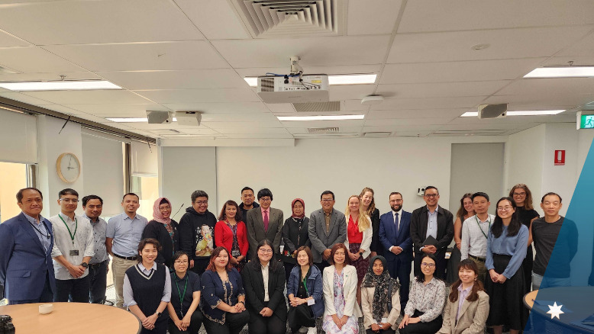
ClimateWorks Centre Fellowship - Southeast Asia Just Energy Transition 2024
Please tell us about any plans you have to hold events (welcome or farewell etc) with at least six week notice. We may be in a position to attend with our Minister, the Minster’s representative or our State Office staff.

Approach to contacting Whole-of-government (WoG) partners

We are keen to encourage engagement between Australia Awards Fellows and institutions with WOG partners but at the request of some key partners, we need to prioritise and streamline engagement. We request that teams who have identified potential opportunities for Australia Awards delegations to engage with other Australian Government Agencies direct all enquiries to Fellowships@dfat.gov.au.

DFAT will make the initial assessment of the opportunity and will work closely with the relevant Government Agency to determine its capacity to host the delegation based on the strategic objective and log a request through our internal networks. For example – training opportunities identified with the APSC as a potential partner, will need to be directed to DFAT in the first instance. Please do not hesitate to us should you need further clarification.

Welcome packs
An Australia Awards Fellowships Welcome Pack is available as a gift for your Fellows on arrival.

Welcome pack includes –

- Backpack
- Fellowships Notebook
- Pen
- Pin
- Tie/Scarf
- Drink bottle

If you did not receive your merchandise, please email us at fellowships@dfat.gov.au. (For Fellowships that are already underway, we will endeavor to get them to you before your Fellows leave where possible.)

Fellowship Completion Certificate
Four weeks prior to completing your Australian Activities, please complete the Fellowships Completion Certificate template on the Australia Awards Resources page and forward it to fellowships@dfat.gov.au. The completion certificates will be professional printed and returned to you to arrange presentation.

Report
You may consider using the Report template found on the Australia Awards Resources page for articles written on your Fellowships program. We recommend that the report should be no longer than three pages.

Record keeping
Please note, that as part of your Australia Awards Fellowships Activity Completion Report you are required to provide a list of all communication activities, so remember to record any initiatives and keep print copies to include in your report.

For further questions and advice, please contact: fellowships@dfat.gov.au

